Command Line
- Pwd (Print working directory): tells us where we are by printing out our current postion in the file tree.
- ls (List items) : lists the contents of the current working directory.
- cd(change director): takes to a new directory {cd }
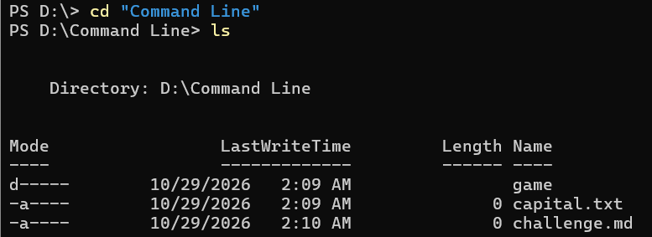

- clear: clears the terminal. Or we can use (cls).
- cd ../ : navigate to another directory of same parent directory
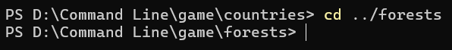

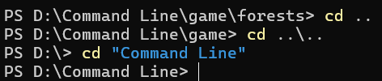
- We use {cd ..} to navigate one step and {cd ..\..} to navigate two step back.

- mkdir : Used to create a directory in current folder
- rmdir: Removes the folder from the current directory(only if selected directory is empty. Else use
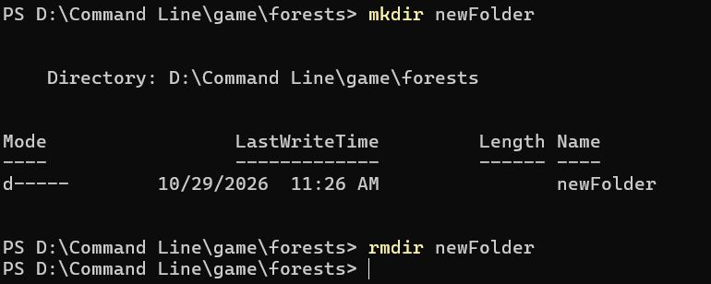
{rm -r folder_name})

- ni (New-Item) : used to create a new file
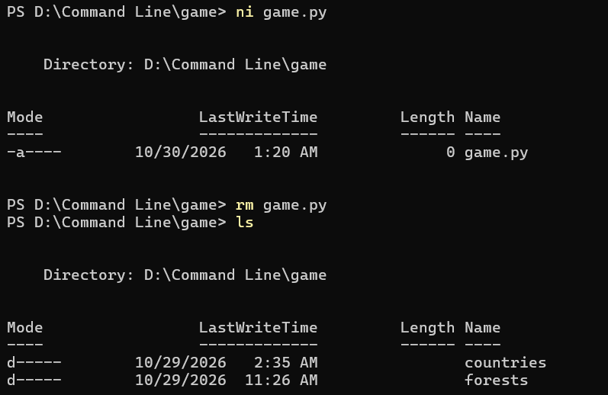
- rm: delete the file.

- echo: | Text print karna

- > | : File mein likhna, purana content replace karna

- >> | : File ke end mein content add karna

- cat | : File ka content dekhna
